How to Add a Pop-up Menu using Fireworks

- Open the Navigation Bar you wish to use
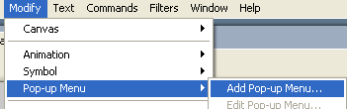
- Highlight the button you wish to add your pop-up menu

- Select Modify > Pop-up Menu > Add Pop-up Menu

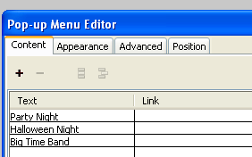
- Add the Text you wish to appear on the menu

- Select the Appearance to change the look of your men

- Select the position tab > select the position you wish the menu to appear
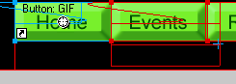
- The pop-up menu will appear in lines like this

- File > Preview in browser > preview in iexplore.exe

